Telerik Trainer 2.3.2.12 Release Notes
This is the Public Release Candidate.

New in this version
This section details the changes to the trainer in this release.

Localized
This version comes with German, English and Swedish localizations. The language to use is detected automatically by the Trainer based off the current system.

Automatic Updates
The Trainer now pulls updates once a day or on demand from an update server. It can update itself (TT.exe and it’s assemblies), the authoring DLL if present, the help file, the help video, and any of the components that is has downloaded (for instance databases, RadControls, reporting…).
The use of components is now specified in Authoring mode and stored in the TTS file, so now the Trainer can handle multiple different RadControl SPs:

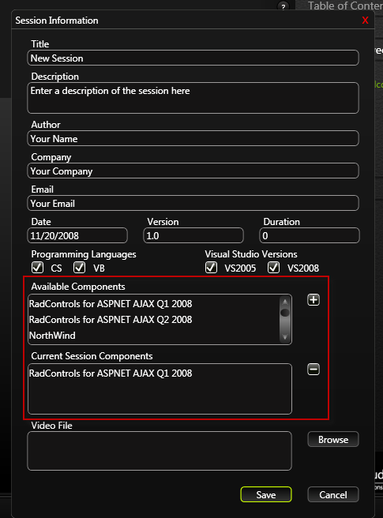
Preferences and on demand updates can be done from the updates tab of the Preferences dialog.
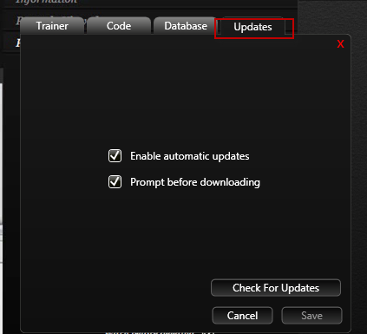
When the Trainer loads a session that needs optional components, for instance RadControls or some database, they are downloaded on the fly if missing locally.

Enhanced database support
The Trainer allows you to configure what database to use. If you have a local SQLServer Express it automatically uses it:
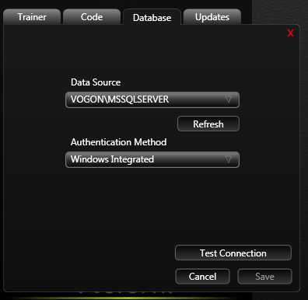
It can find any servers that are local or are on the network and allow browsing. You can configure how to connect (Windows Integrated is default), and test your connection.
When the trainer loads a session that uses a database, it downloads it if not already present, and automatically attached it to the SQL Server (if local). It then changes the config file of the loaded session so it points to the database and uses your configured authentication. So now database examples work automagically with no configuration.
Added support for SQL Server 2008.

Updated help
The help files have been updated to reflect the new features

New Preferences dialog
Preferences are now organized in a tabbed modal preferences dialog.

New about dialog
The about information is now in a modal dialog

Better support for Windows Vista with UAC on
The trainer now has signed files (we need you to sign them instead with Teleriks real certificate) and uses a Manifest, these two changes cause it to function properly under Vista with UAC turned on.

New NET Framework Version
We now use .NET Framework 3.5 SP1 which has a number of performance enhancements for WPF. The installer requires 3.5 SP1.

Bug Fixes:
- Fixed references to old assemblies in the installer project and the BootStrapUtiltiy.
- Moved BootStrapUtility into the main TT.CAB. This fixed an error when both the BootStrapUtility and the main app get an autoupdate.
- Fixed a bug with the message dialog sometimes getting hidden behind the main page and effectively locking the application.
- Fixed a bug in both the client and server that prevented more than one bootstrapped CAB update at a time.
- Updated position and size of various preferences control to better handle localization strings.
- Added a culture dropdown list to the preferences dialog that allows the user to choose between selecting the culture automatically or between supported cultures.

