Data Services Wizard | 2009
 | Telerik OpenAccess DSW Getting Started



Contents
Introduction 4
How it works 4
Generation Process 5
Data Access Layer Project 5
Output Project 5
Generated Service Language 5
Generating ADO.Net Data Service for .NET 3.5 SP1 and .Net 4 Version 1 (Astoria) 6
Entities dependencies 6
Generated Files 6
DAL service keys 6
Data Manager 7
Service Markup 8
Service Code Behind 9
References 9
Generated Service Output view 9
Generating ADO.Net Data Service for .NET 3.5 SP1 Version 2 (Astoria) 11
Entities dependencies 11
Generated Files 11
DAL service keys 11
Data Manager 12
Service Markup 13
Service Code Behind 14
References 14
Generated Service Output view 14
Generating WCF endpoints service 16
Generated Files 16
Data Manager 16
Service Contract Interface 16
Service Markup 17
Service Code Behind 17
Configuration File “Web.Config” 17
Cyclic Reference Serialization Support 18
CyclicDataContractSerializer 18
CyclicReferencesAwareContract 18
CyclicReferencesAwareAttribute 18
References 19
Generated Service Output view 19
Generating REST Collection WCF Service 19
Generated Files 19
Data Manager 19
ICollectionService 20
Service Markup 21
App Service Host Factory 21
Service Code Behind 22
References 22
Generated Service Output view 23
View Data in JSON format 23
Generating Atom Publishing Protocol WCF Service 24
Generated Files 24
Data Manager 24
Service Markup 24
Service Code Behind 25
References 26
Generated Service Output view 26

Introduction
Telerik OpenAccess ORM offers the developer a tremendous benefit by providing the data access plumbing in web and Windows applications. A best practice is to separate your data tier from your UI and business tiers and communicate via a service, such as WCF. In addition to WCF many developers are also using RESTful services such as ADO.NET Data Services or the REST capabilities build into WCF via the WCF REST Starter Kit Preview 2.
In order to work with these technologies, the developer has to create the service endpoints, a pretty generic but manual and time consuming task. The Telerik Data Services Wizard is a tool that will automatically create the C# or VB code and necessary project files for using OpenAccess entities with the following services, saving the developer time and eliminating syntax errors and bugs:
- Data Services for .NET 3.5 SP1 Version 1 (Astoria).
- Data Services for .NET 3.5 SP1 Version 2 (Astoria).
- WCF Endpoints Service.
- REST Collection WCF Services.
- ATOM Publishing Protocol WCF Service.

How it works
Telerik OpenAccess Data Services Wizard is an Add-on to Telerik OpenAccess ORM; once you installed the wizard (Whether you are using Visual Studio 2008 or Visual Studio 2010) you will be able to find Data Services Wizard under Telerik menu.
Open new class library project, enable it for using Telerik OpenAccess ORM, do reverse mapping or create your classes then do forward mapping, by then you will have your data access layer ready.
Create new Web Application or Web Site, then open Telerik data Services wizard, you will notice that the wizard loads the valid data access layers project types in input list, and valid output project types in output list.
By click next you will be able to see data service picker screen, which enables you to:
- Select the type of data service to generate,
- Select which entities you want this service to interact with,
- Select the generated service language in case the selected output project is a website.
- Preview the generated files content before saving it to the project
The last step of the wizard shows you the summary on generation process and it includes the following:
- Selected entities for generation.
- Files will be added to Output project
- Files will be added to Data Access Layer
- References will be added to Output project
- References will be added to Data Access Layer

Generation Process
The wizard simply store a bunch of T4 templates in installation directory for each data service that the wizard are working with, and each data service is provider has its own configuration, templates, usage requirements and set of references.
Each provider uses external T4 host engine to bind the templates with parameters from the wizard (like selected entities, service namespace … etc), the wizard generates the files first in the wizard temp store, then it copies them to the output project.

Data Access Layer Project
In order to start using Telerik OpenAccess Data Service Wizard you need to create a data access layer built with Telerik OpenAccess:
- DAL should be any visual studio project that compiles to an assembly, like Class Library, Windows Application, Web Application … etc.
- DAL should contain Object Context Provider as the generated Service always relays on it to communicate with entities generated in the data access layer, so if you forgot to check “Data Access Classes” check box, you can back and to DAL project and right click, choose OpenAccess then choose Add IObjectConext Provider.

Output Project
Output project could be a web application or a website, and this project will be where the generated service files are stored and required reference for this service will be added.

Generated Service Language
The wizard detects the output project language and it will select by default output project language, but in case the output project is a website you will be able to choose the output project language weather it is C# or VB.

Generating ADO.Net Data Service for .NET 3.5 SP1 and .Net 4 Version 1 (Astoria)
It‘s the regular ADO.Net Data Service that shipped with .net framework 3.5 and .net framework 4.0, developer can easily can go through the wizard choosing the data access layer, and choosing output project then more step to choose the service type, service language and which entities to generate, and also there an option to preview the files before generating them.

Entities dependencies
If you tried to generate some entities and those entities has some properties are not primitive types, and types of those entities are entities located in the DAL but not selected the wizard will notify you and generate them automatically, ex:
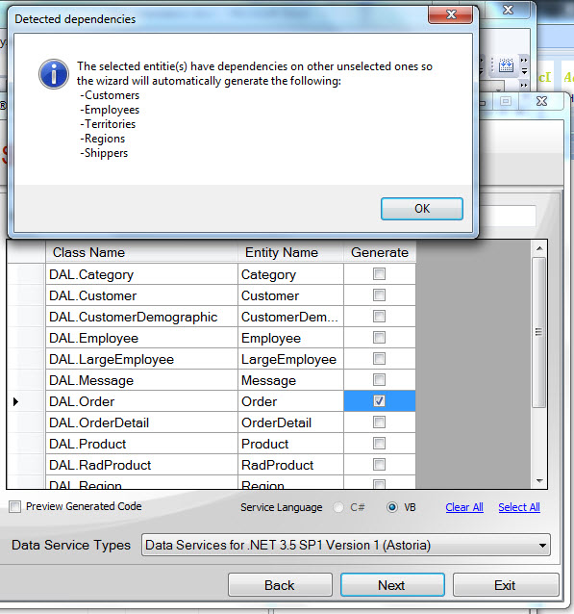

Generated Files
By Generating ADO.net service, there are some files will be generated to the DAL and others will be generated in the output project.

DAL service keys
ADO.net service is identifying IQueryable entities by its primary key, and it recognizes this primary key and defines it as a Data Service Key, by checking the matching one of the following keywords:
- Id
- ID
- [Table Name] + Id
- [Table Name] + ID
If the developers wants to generate a ADO.net service that will interact with an entity has a complex identity, like an entity that represents a bridge table; or this entity has a primary key doesn’t following the previous convention, so the developer need to mark this entity with DataServiceKey attribute and define this entity identity as a string of this property name in the entity class which matches the primary key name, and if the entity identity is complex (consists of more than one field) the user should define array of strings that represents each property name in the entity class which matches a field in this complex identity.
Telerik OpenAccess DSW generates this file automatically in the DAL and it contains a partial declaration for each class marked with DataServiceKey attribute holds the identity for this entity, ex:
/// <summary>
/// Order Class Data Service Key Fix
/// </summary>
[DataServiceKey("OrderID")]
public partial class Order
{
}

/// <summary>
/// OrderDetail Class Data Service Key Fix
/// </summary>
[DataServiceKey(new string[]{"OrderID","ProductID"})]
public partial class OrderDetail
{
}

Data Manager
DataManager file is a simply is the core of the services and it controls all the data manipulation between the Telerik OpenAccess ORM entities in DAL and the generated service and data manager class implements the following interfaces:
- IDisposable,
- ICloneable,
- IUpdatable
public partial class DataManager : IDisposable, ICloneable, IUpdatable
There is a public IQueryable property that represents each entity in DAL; ex:
/// <summary>
/// Gets the Customers.
/// </summary>
/// <value>The Customers.</value>
public IQueryable<ClassLibrary2.Customer> Customers
{
get
{
return this.scope.Extent<ClassLibrary2.Customer>();
}
}
/// <summary>
/// Gets the CustomerDemographics.
/// </summary>
/// <value>The CustomerDemographics.</value>
public IQueryable<ClassLibrary2.CustomerDemographic> CustomerDemographics
{
get
{
return this.scope.Extent<ClassLibrary2.CustomerDemographic>();
}
}

Service Markup
The markup file for the generated service; ex:
<%@ ServiceHost Language="C#" Factory="System.Data.Services.DataServiceHostFactory, System.Data.Services, Version=3.5.0.0, Culture=neutral, PublicKeyToken=b77a5c561934e089" Service="WebApplication1.SampleServiceName" %>

Service Code Behind
The service code behind where Telerik OpenAccess DSW assigns the Data Service Class to the generated DataManager class.
public partial class SampleServiceName : DataService<DataManager>
{
/// <summary>
/// Initializes the service.
/// </summary>
/// <param name="config">The config.</param>
public static void InitializeService(IDataServiceConfiguration config)
{
config.SetEntitySetAccessRule("*", EntitySetRights.All);
}

References
The following references will be added to DAL project and output project as well:
- System.Data.Entity.dll
- System.Data.Services.dll
- System.Data.Services.Client.dll
- System.ServiceModel.dll
- System.ServiceModel.Web.dll

Generated Service Output view
After finishing generating the service you can right-click on the service markup file “servicename.svc” and view it browser, you will be to see a an XML of Atom Syndication Format, listing atom feed for each generated entity, ex:
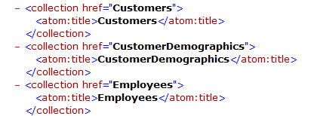
So to view the entity feed itself, you need to write the entity name after the service name in the URL:
Ex: http://localhost:2853/SampleServiceName.svc/Customers
Then you will see atom feed for this entity, so to see the XML representation for this feed you can right click on the page and select view page source, or if you are using IE8 you can go to internet options then choose content and select Feeds and Web Slices setting and uncheck Turn on feed reading view.
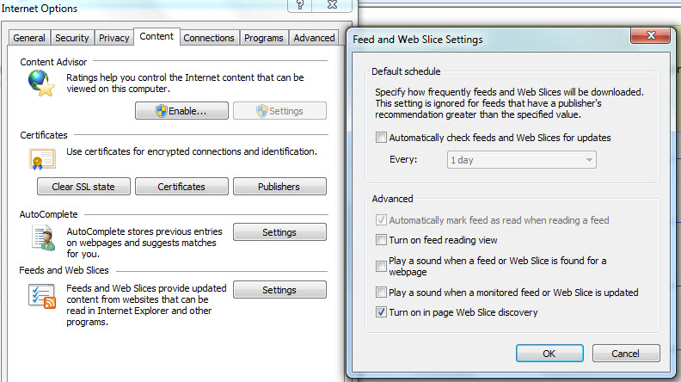
Then press ok and refresh the service page and you will see the XML representation for this Atom feed for this entity, ex:
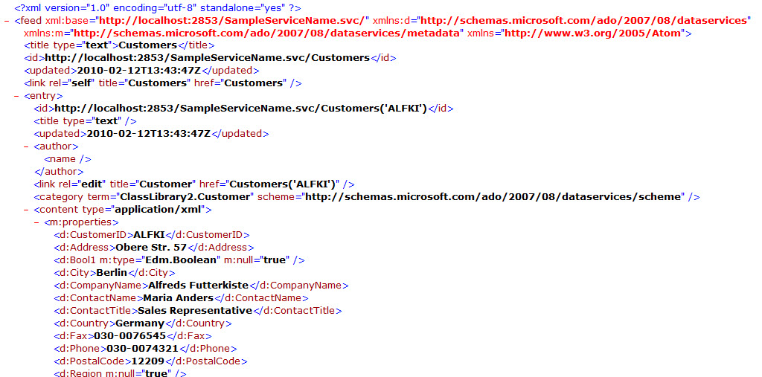

Generating ADO.Net Data Service for .NET 3.5 SP1 Version 2 (Astoria)
It‘s the update for ADO.Net Data Service that shipped with .net framework 3.5, and you can download it form here (http://www.microsoft.com/downloads/details.aspx?familyid=79D7F6F8-D6E9-4B8C-8640-17F89452148E&displaylang=en); developer can easily can go through the wizard choosing the data access layer, and choosing output project then more step to choose the service type, service language and which entities to generate, and also there an option to preview the files before generating them.

Entities dependencies
If you tried to generate some entities and those entities has some properties are not primitive types, and types of those entities are entities located in the DAL but not selected the wizard will notify you and generate them automatically, ex:

Generated Files
By Generating ADO.net service, there are some files will be generated to the DAL and others will be generated to the output project.

DAL service keys
ADO.net service is identifying IQueryable entities by its primary key, and it recognizes this primary key and defines it as a Data Service Key, by checking the matching one of the following keywords:
- Id
- ID
- [Table Name] + Id
- [Table Name] + ID
If the developers wants to generate a ADO.net service that will interact with an entity has a complex identity, like an entity that represents a bridge table; or this entity has a primary key doesn’t following the previous convention, so the developer need to mark this entity with DataServiceKey attribute and define this entity identity as a string of this property name in the entity class which matches the primary key name, and if the entity identity is complex (consists of more than one field) the user should define array of strings that represents each property name in the entity class which matches a field in this complex identity.
Telerik OpenAccess DSW generates this file automatically in the DAL and it contains a partial declaration for each class marked with DataServiceKey attribute holds the identity for this entity, ex:
/// <summary>
/// Order Class Data Service Key Fix
/// </summary>
[DataServiceKey("OrderID")]
public partial class Order
{
}
/// <summary>
/// OrderDetail Class Data Service Key Fix
/// </summary>
[DataServiceKey(new string[]{"OrderID","ProductID"})]
public partial class OrderDetail
{
}

Data Manager
DataManager file is a simply is the core of the services and it controls all the data manipulation between the Telerik OpenAccess ORM entities in DAL and the generated service and data manager class implements the following interfaces:
- IDisposable,
- ICloneable,
- IUpdatable
public partial class DataManager : IDisposable, ICloneable, IUpdatable
There is a public IQueryable property that represents each entity in DAL; ex:
/// <summary>
/// Gets the Customers.
/// </summary>
/// <value>The Customers.</value>
public IQueryable<ClassLibrary2.Customer> Customers
{
get
{
return this.scope.Extent<ClassLibrary2.Customer>();
}
}
/// <summary>
/// Gets the CustomerDemographics.
/// </summary>
/// <value>The CustomerDemographics.</value>
public IQueryable<ClassLibrary2.CustomerDemographic> CustomerDemographics
{
get
{
return this.scope.Extent<ClassLibrary2.CustomerDemographic>();
}
}

Service Markup
The markup file for the generated service; ex:
<%@ ServiceHost Language="C#" Factory="System.Data.Services.DataServiceHostFactory, System.Data.Services, Version=3.5.0.0, Culture=neutral, PublicKeyToken=b77a5c561934e089" Service="WebApplication1.SampleServiceName" %>

Service Code Behind
The service code behind where Telerik OpenAccess DSW assigns the Data Service Class to the generated DataManager class.
public partial class SampleServiceName : DataService<DataManager>
{
/// <summary>
/// Initializes the service.
/// </summary>
/// <param name="config">The config.</param>
public static void InitializeService(DataServiceConfiguration config)
{
config.SetEntitySetAccessRule("*", EntitySetRights.All);
config.DataServiceBehavior.MaxProtocolVersion =
System.Data.Services.Common.DataServiceProtocolVersion.V2;
}

References
The following references will be added to DAL project and output project as well:
- System.Data.Entity.dll
- System.Data.Services.dll
- System.Data.Services.Client.dll
- System.ServiceModel.dll
- System.ServiceModel.Web.dll

Generated Service Output view
After finishing generating the service you can right-click on the service markup file “servicename.svc” and view it browser, you will be to see a an XML of Atom Syndication Format, listing atom feed for each generated entity, ex:
So to view the entity feed itself, you need to write the entity name after the service name in the URL:
Ex: http://localhost:2853/SampleServiceName.svc/Customers
Then you will see atom feed for this entity, so to see the XML representation for this feed you can right click on the page and select view page source, or if you are using IE8 you can go to internet options then choose content and select Feeds and Web Slices setting and uncheck Turn on feed reading view.
Then press ok and refresh the service page and you will see the XML representation for this Atom feed for this entity, ex:

Generating WCF endpoints service
A regular endpoints WCF service, with Service Contract and operation contracts you can start it weather you are using Visual Studio 2008 or Visual Studio 2010; the wizard generate this service to manage the entities in the DAL throw the data manager generic CRUD operations.

Generated Files
By Generating WCF Endpoint service, the files will be generated to the output project.

Data Manager
DataManager class file contains generic CRUD operations which are usable for any entity in the generated service, ex:
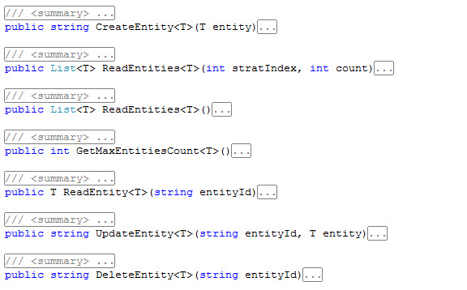

Service Contract Interface
It’s the service contract which has the operation contract for CRUS Operations for each entity, ex:

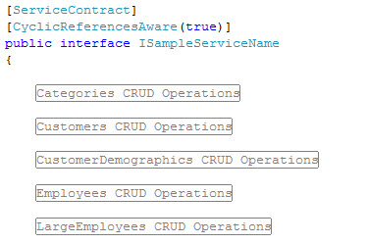

Service Markup
The markup file for the generated service; ex:
<%@ ServiceHost Language="C#" Debug="true" Service="WCFEndPoints.SampleServiceName"
CodeBehind="SampleServiceName.svc.cs" %>

Service Code Behind
The service code behind class file which implements the service contract interface and it uses an instance from DataManager to call each CRUD operation for each entity.

Configuration File “Web.Config”
The tool always modified the Web.Config file and add it the Service Model configuration, ex:
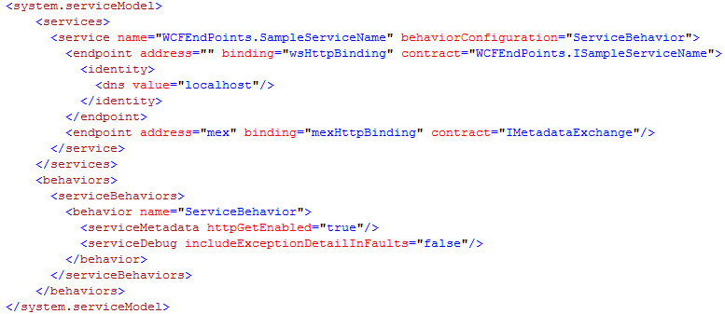

Cyclic Reference Serialization Support
If you are trying to make a WCF service, you may run into cyclic reference issue, when you have an object as a parent and this parent have collection of children, and each child holds a property reference to its parent so When the DataContractSerializer attempts to serialize the parent and children, you’ll soon discover that the cyclic relationship between the parent and its children and back to the parent will cause a stack overflow; Below is a basic diagram that shows a basic parent to child – child to parent object (cyclic) relationship where this can occur
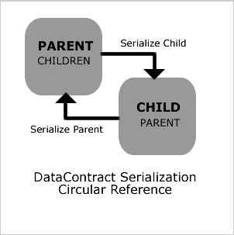
So to fix this issue in our generated WCF Service, the wizard generates extra support classes:

CyclicDataContractSerializer
It’s an operation behavior being used to inject custom configured DataContractSerializer instances into WCF pipeline.

CyclicReferencesAwareContract
It’s a contract behavior and it’s used to apply the CyclicDataContractSerializer operation behavior to every operation within a contract.

CyclicReferencesAwareAttribute
It’s used to apply cycling support policy to the whole service interface or an individual interface operation.
For more information about cyclic reference issue in WCF please see:
- http://chabster.blogspot.com/2008/02/wcf-cyclic-references-support.html
- http://blogs.msdn.com/sowmy/archive/2006/03/26/561188.aspx
- http://www.mostlydevelopers.com/mostlydevelopers/blog/post/2009/02/03/Fixing-WCF-Circular-Reference-Serialization.aspx

References
The following references will be added to output project:
- System.ServiceModel.dll
- System.Runtime.Serialization.dll

Generated Service Output view
By right click on the service markup file and view it in browser you can see the service help page, and there is a link to see the WSDL of the service.
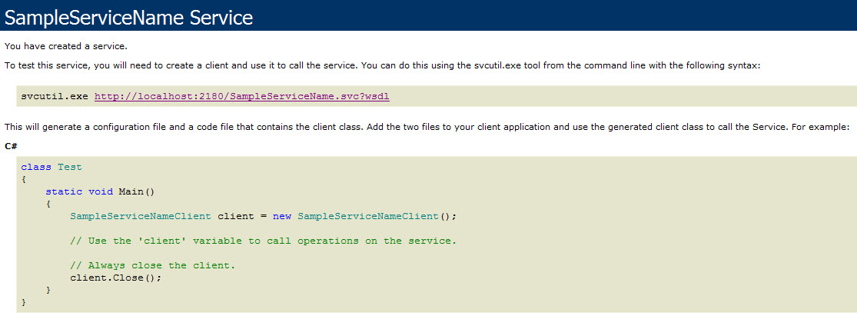

Generating REST Collection WCF Service
REST Collection WCF service is a regular WCF service but without endpoints, as you will be invoking it through REST, you can use it in Visual Studio 2008 as long as you have WCF REST Starter Kit Preview 2 (get it from here: http://aspnet.codeplex.com/releases/view/24644 ) installed to your machine, and you will be able to use it in visual studio 2010 without installing any additional software; the wizard will generating a WCF REST Service for each entity.

Generated Files
By Generating REST Collection WCF Service, the files will be generated to the output project.

Data Manager
DataManager class file contains generic CRUD operations which are usable for any entity in the generated service, ex:

ICollectionService
The service contract file which includes all operation contracts that the service will be used to be invoked through REST and you will only be able to see this file when using Visual Studio 2010 to generate REST collection Service from Telerik OpenAccess Data Services Wizard, ex:
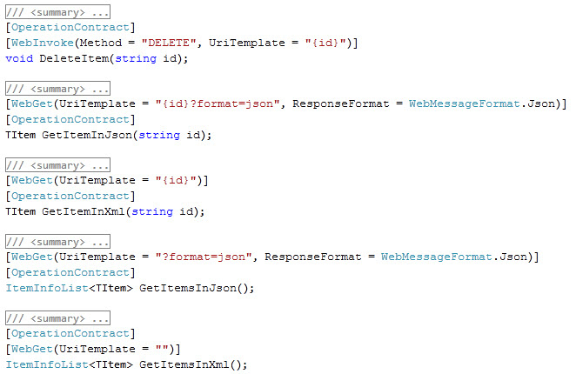

Service Markup
The markup file for the generated service; ex:
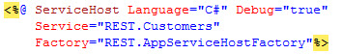

App Service Host Factory
Used to invoke the service as REST, ex:
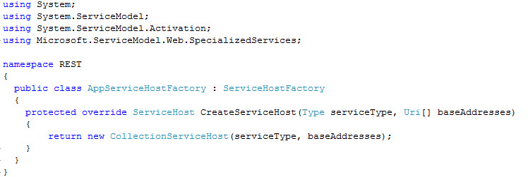

Service Code Behind
The Service class file is always implementing CollectionServiceBase and ICollection Service and this class and interface are from WCF REST Starter Kit, that only if the user using visual studio 2008 and if the user is using visual studio 2010 the service will be implementing only ICollectionServiceBase which is a service is built to simulate the one was built in WCF REST Starter Kit, ex:
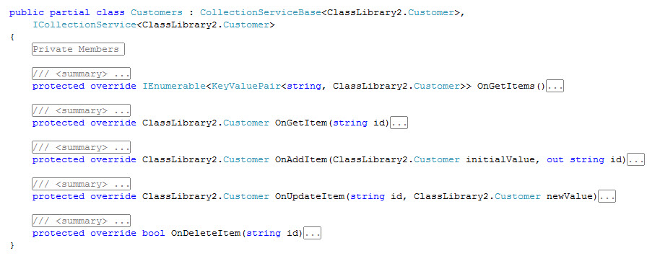

References
The following references will be added to output project:
- Microsoft.ServiceModel.Web.dll
- System.ServiceModel.dll
- System.ServiceModel.Web.dll
- System.Runtime.Serialization.dll

Generated Service Output view
The wizard will generate a WCFREST Service for each entity, to start view the output you can simple right click on the service and view it in browser ex:
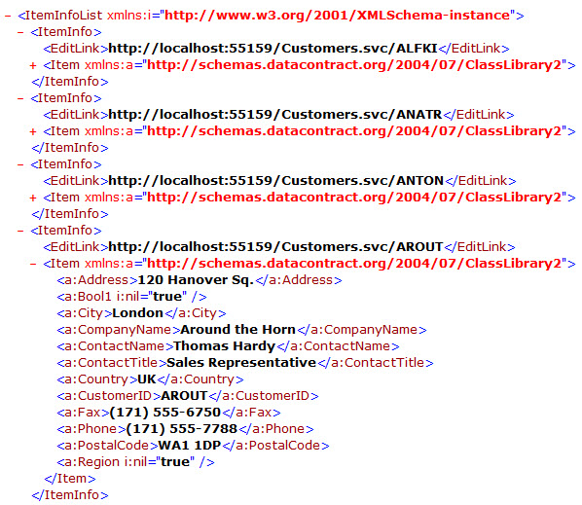
And you can simply view each data row inside this entity by query on (Service URL) / entity ID and this will be found in EditLink Meta Tag for each entity.

View Data in JSON format
REST collection service provide another format for the retrieved the data and its JSON format, all what you need to add to retrieve the data in JSON format is adding “format=json” after the query URL, ex “http://localhost:55159/Employees.svc?format=json“ and in this case it will return the data in JSON format, and it will be a downloadable file, when you open it on Notepad you will the data in JSON format, ex:
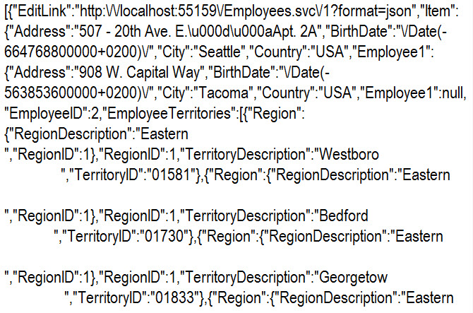

Generating Atom Publishing Protocol WCF Service
Atom publishing protocol WCF service is another WCF service from WCF REST Starter Kit, uses System.ServiceModel.Syndication to construct an atom feed, the wizard enables the developer to set which field to be the title and which field to be the description, and all the entity data will be stored in content tag in inside atom feed.

Generated Files
By Generating Atom Publishing Protocol WCF service, all the files will be generated in the output project.

Data Manager
DataManager class file contains generic CRUD operations which are usable for any entity in the generated service, ex:

Service Markup
The markup file for the generated service; ex:
<%@ ServiceHost Language="C#" Debug="true" Service="WebApplication3.SampleServiceName"
Factory="WebApplication3.AppServiceHostFactory" %>
And it uses its own ServiceHostFactory if you are using Visual Studio 2008, ex: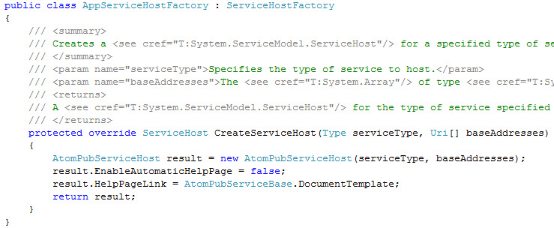
But if you are using Visual Studio 2010, it will use WebServiceHostFactory from System.ServiceModel.Activiation Library, ex:

Service Code Behind
The service code behind class file, implement the Service Contract Interface and also it contains the core methods that the service will use to create the feed.
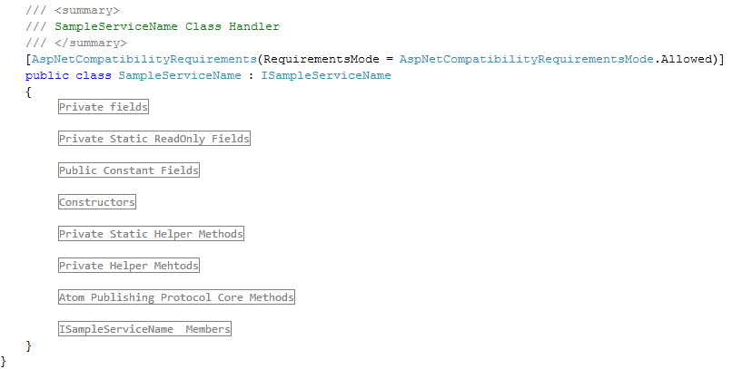

References
The following references will be added to output project:
- Microsoft.ServiceModel.Web.dll
- System.ServiceModel.dll
- System.ServiceModel.Web.dll
- System.Runtime.Serialization.dll

Generated Service Output view
By right click on the service markup file and view in browser, you will see an Atom Feed holds the entity information, title and description for each entity that were assigned, and if you turn the feed reading view off or view the page content in browser you will be able to see the data for each entry stored o content tag of the each entry, ex:
The entire atom feeds listed:
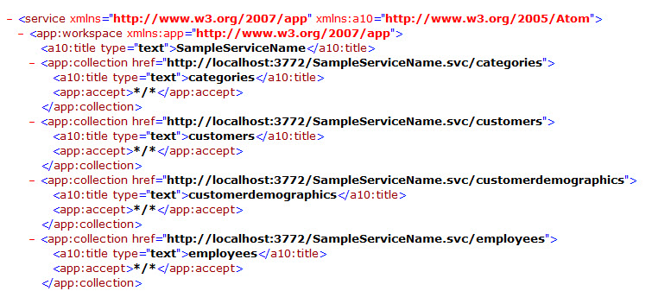
The feed of each entity will look like the following:
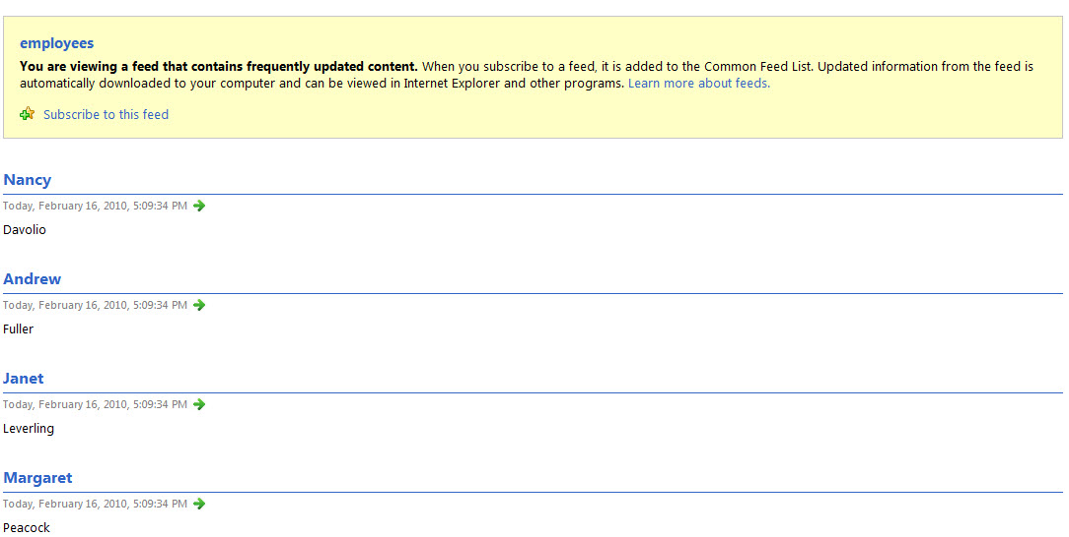
If you turn off Feed reading view, or view page source you will see the entity data stored in each entry Content Tag
